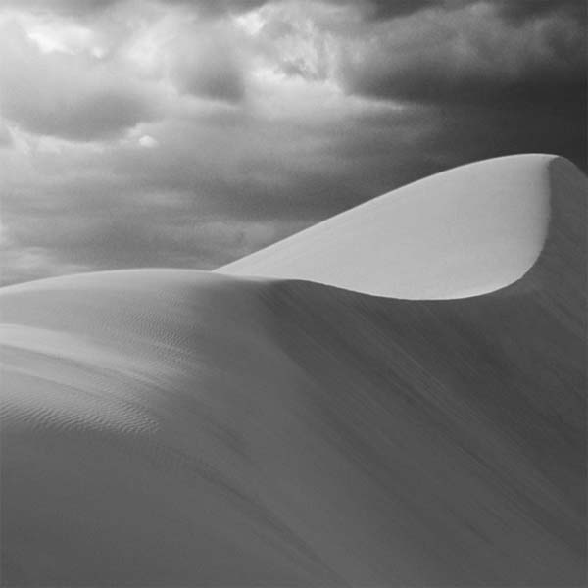
Procedures:
- Right click on the photo and copy the image (Control + C)
- Open Photoshop and paste the image (Control + V)
- Change the color from grayscale to RGB – Image>Mode>RGB
- In the ‘layers’ palette, add 2 new layers (top right corner drop down) and name them “sky” and “dune”. You may delete your background layer if it is plain white.
- Select the “sky” layer.
- In your color picker (bottom left of your screen), double click on the foreground picker and choose a blue color for the sky. Double click on the background picker and choose a color for the sand.
- Using your pen tool, trace the sky and come back to the beginning anchor point. Use ALT +Click to deselect the right handle of the pen tool, so that you can make a smooth, continuous line.
- Click on ‘Paths’ – next to the Layer Palette
- Click on the “selection” (dashed circle at the bottom of the Path Palette)
- Your line you made should now have “marching ants”, meaning it has been selected
- Go to Edit>Fill>Choose with ‘foreground color’.
- In the Layers palette, change the layer from ‘normal’ to ‘color’ (bottom of the drop down menu). This will allow the shapes of the clouds to show through your color.
- Select your Dune layer.
- Go to the Paths palette and make a new path (same as making a new layer)
- Select your path again using the dashed circle
- At the top, Select>Inverse
- Color your dune the same way as your sky, but you will need to use your ‘background color’ instead of your foreground color. (See steps10, 11, &12).
- Save your image as a JPEG file and email it to your instructor.

